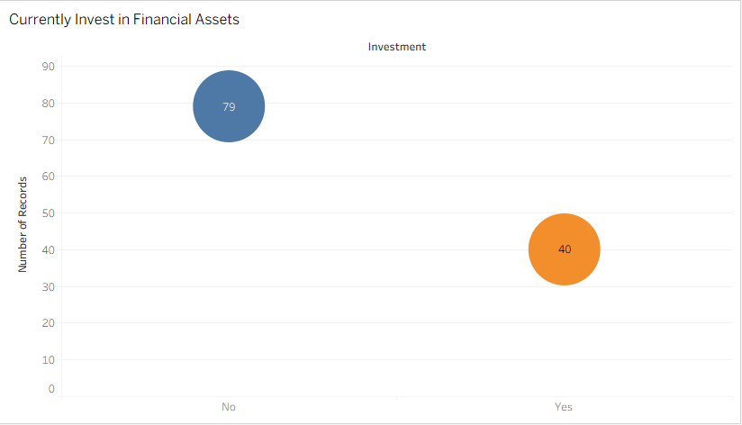

What the Chart Tells Us
The chart shows that 79 respondents (66.4%) do not currently invest in financial assets, while 40 respondents (33.6%) are actively investing. This indicates that a large portion of the surveyed population has limited participation in financial markets.
Interpretation
The results suggest that financial investment activity among respondents is relatively low, with most individuals not yet engaged in traditional investment options such as stocks, bonds, or digital assets. This may reflect limited financial exposure, lack of awareness, or cautious financial behaviour. However, the presence of a smaller group of active investors indicates that some level of investment experience already exists, which could support the potential adoption of new financial instruments such as TER if awareness and trust increase.

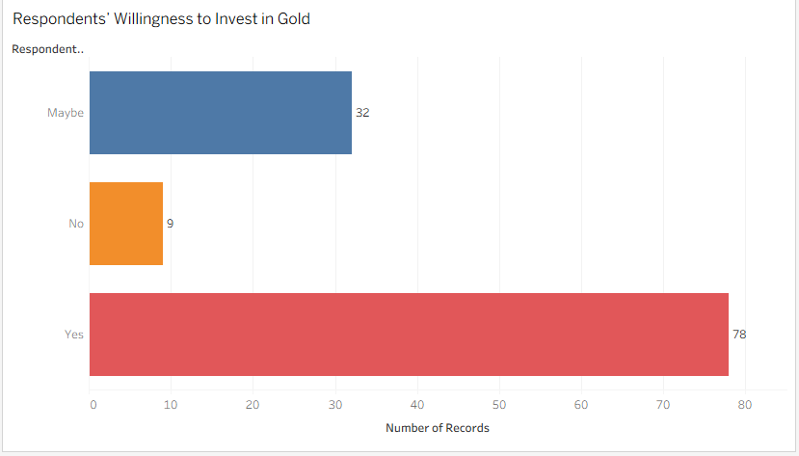
What the Chart Tells Us
The chart shows that 78 respondents expressed willingness to invest in gold, while 32 respondents indicated they might invest, and 9 respondents said they would not invest in gold. This demonstrates that a strong majority of participants show positive or potential interest in gold investment.
Interpretation
The high level of interest in gold suggests that respondents generally trust gold as a stable and reliable store of value. This is important in the context of TER, as the asset is backed by gold. The results imply that linking a digital asset to gold may increase confidence and acceptance among potential users, since gold already holds strong credibility as an investment asset.

Market Stability Analysis
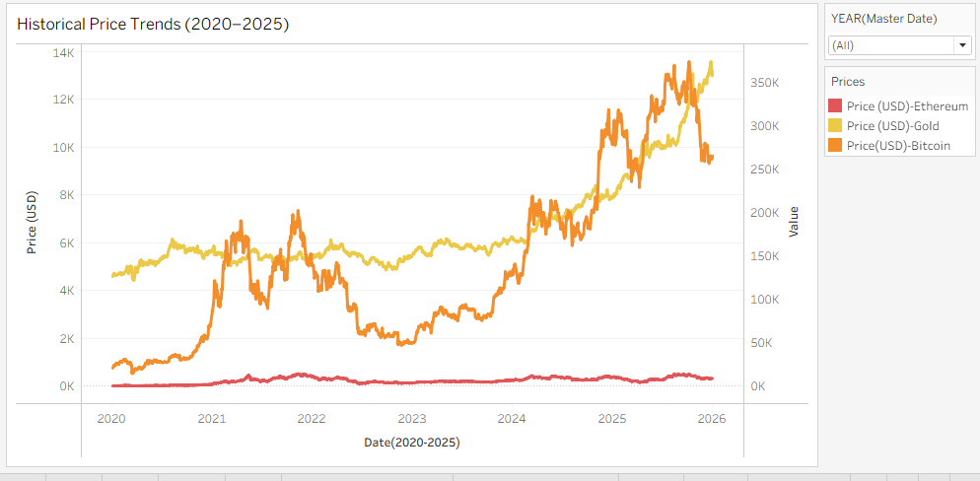
What it shows:
A time-series comparison of Gold, Bitcoin, and Ethereum prices from 2020 to 2025.
Key insights:
Bitcoin shows the highest volatility, with sharp rises (2021, 2024–2025) and major corrections (2022).
Ethereum follows a similar pattern to Bitcoin but at a smaller scale.
Gold remains relatively stable, with gradual upward movement and fewer sharp fluctuations.
2022 reflects a broad crypto downturn.
2024–2025 shows strong recovery and new highs in crypto markets.
Interpretation:
Gold demonstrates long-term stability, while cryptocurrencies provide higher growth potential but with significantly higher risk.

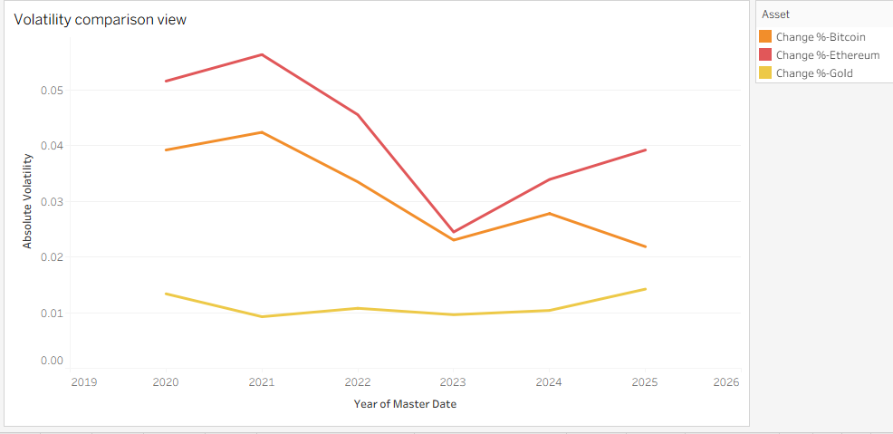
What it shows:
Annual absolute volatility comparison between Bitcoin, Ethereum, and Gold.
Key insights:
Ethereum has the highest volatility overall, especially around 2021.
Bitcoin shows high but slightly lower volatility than Ethereum.
Gold maintains consistently low volatility across all years.
Volatility declines in 2023, then slightly increases again in 2024–2025.
Interpretation:
Crypto assets experience large price swings year-to-year, while gold remains stable. This supports the idea that gold-backed assets (like TER in your study) may inherit lower volatility characteristics.

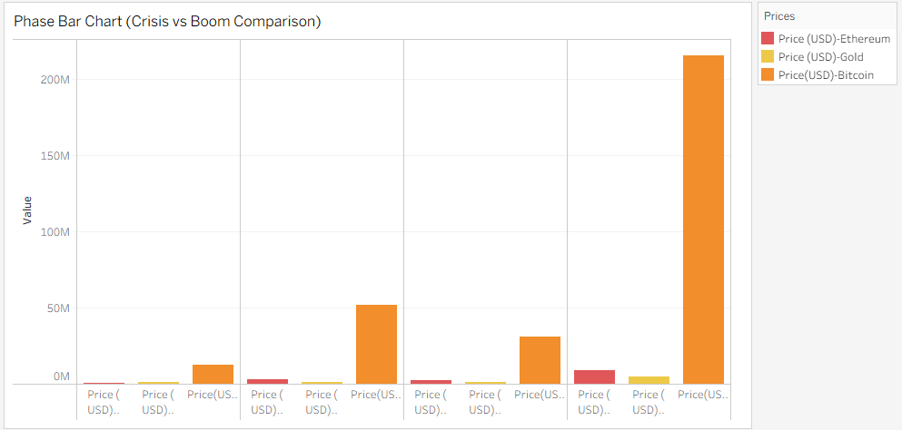
What it shows:
Comparison of asset performance across different market phases (Crisis vs Boom periods).
Key insights:
During boom phases, Bitcoin shows extremely high total value growth compared to Gold and Ethereum.
In crisis phases, crypto values drop significantly.
Gold remains relatively stable in both crisis and boom periods.
The scale difference highlights how dominant Bitcoin price movement is compared to the other assets.
Interpretation:
Cryptocurrencies outperform during expansion phases but suffer large corrections during downturns. Gold acts as a stabilizing asset across cycles.

Survey Analysis.
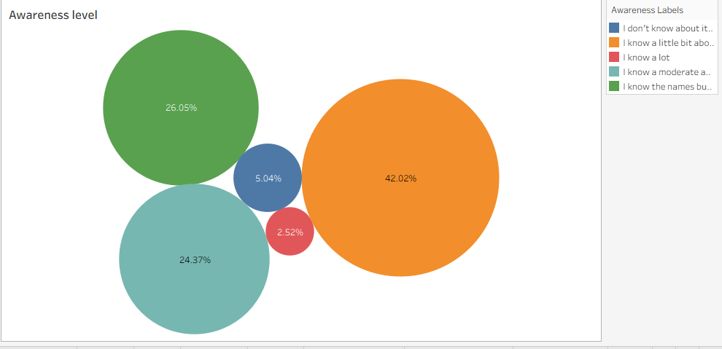
What it shows:
This chart presents the level of awareness about TER among respondents. The size of each bubble represents the percentage of respondents in each awareness category.
Key Findings:
42.02% of respondents know a little bit about TER (largest group).
26.05% know the names but not details.
24.37% have moderate awareness.
Only 5.04% don’t know about it at all.
A very small percentage (2.52%) report very high awareness.
What it tells us:
General awareness exists, but it is mostly basic-level knowledge.
Deep understanding of TER is still limited.
There is strong potential for education and awareness campaigns.
TER is not completely unknown — but it is not yet deeply understood.

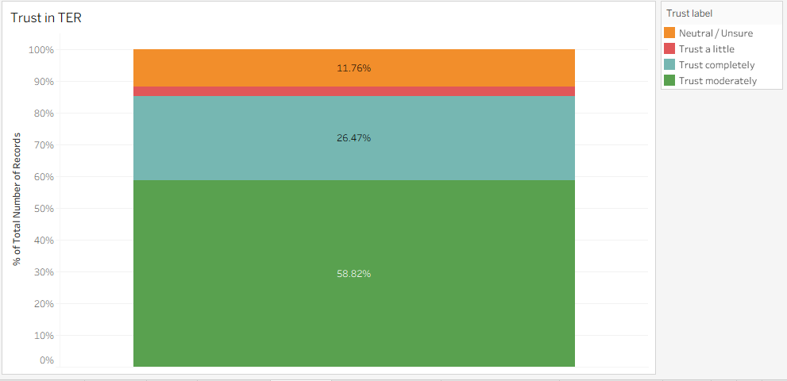
What it shows:
This chart illustrates respondents’ level of trust in TER, shown as a percentage distribution.
Key Findings:
58.82% trust TER moderately (majority).
26.47% trust it completely.
11.76% are neutral or unsure.
A very small percentage trust it only a little.
What it tells us:
Overall trust sentiment is positive.
More than 85% of respondents show moderate to strong trust.
Very few respondents express low trust.
Even though awareness may be basic, confidence in the concept is relatively strong.
This suggests that people may trust the idea of a gold-backed digital asset even if they don’t fully understand it yet.

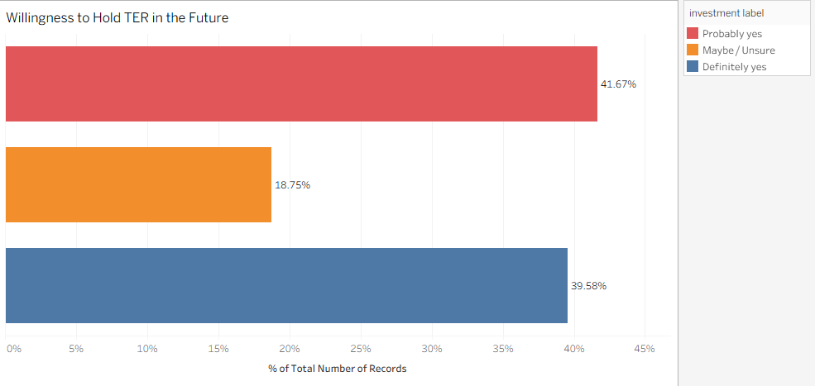
What it shows:
This chart measures respondents’ future investment intention toward TER.
Key Findings:
41.67% say “Probably yes.”
39.58% say “Definitely yes.”
18.75% are unsure.
What it tells us:
Strong investment potential exists.
Over 80% show positive intention to hold TER in the future.
Hesitation is relatively low.
The market readiness appears promising if awareness improves.
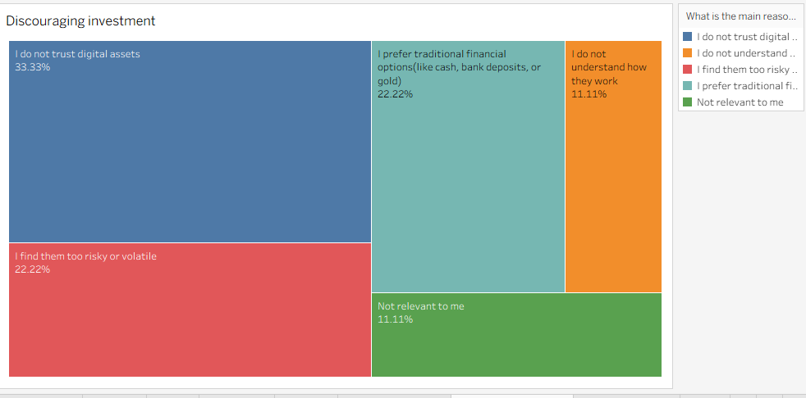
What the chart shows
This treemap illustrates the main reasons why people hesitate or avoid investing in digital assets.
Key insights
The largest concern is lack of trust in digital assets (33.33%), indicating that many respondents are skeptical about the reliability or safety of digital currencies.
22.22% believe digital assets are too risky or volatile, reflecting concerns about price fluctuations commonly seen in cryptocurrencies.
Another 22.22% prefer traditional financial options such as cash, bank deposits, or gold, suggesting people are more comfortable with familiar financial systems.
11.11% do not understand how digital assets work, showing a knowledge gap.
11.11% feel digital assets are not relevant to them, meaning they may not see a practical use or benefit.
Overall interpretation
The chart suggests that trust, perceived risk, and preference for traditional financial systems are the biggest barriers to digital asset adoption. Improving financial literacy and building trust could increase adoption.

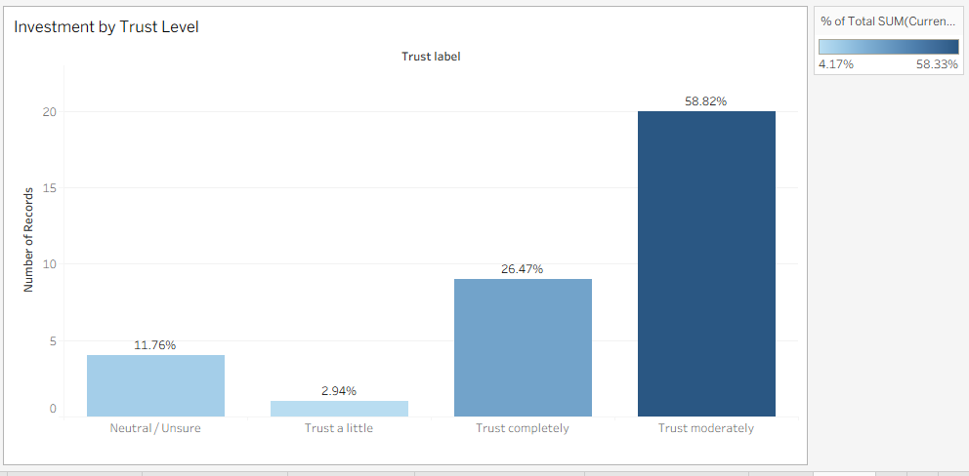
What the chart shows
This bar chart presents how respondents’ level of trust in digital assets relates to whether they currently invest in financial assets.
Key insights
The largest share of current investors falls under moderate trust (58.33%), indicating that people who have a reasonable level of confidence in digital assets are the most likely to invest.
26.08% of respondents who currently invest trust digital assets completely, showing that strong trust further supports investment participation.
10.42% of investors are neutral or unsure, suggesting that some individuals still invest even while evaluating or learning about digital assets.
Only 4.17% of investors trust digital assets a little, indicating that very low trust corresponds with lower investment participation.
Overall interpretation
The chart suggests a positive relationship between trust and investment behavior. As trust in digital assets increases, from little trust to moderate or complete trust—the likelihood of investing also increases. This highlights the importance of building trust and transparency in digital financial systems to encourage wider adoption.

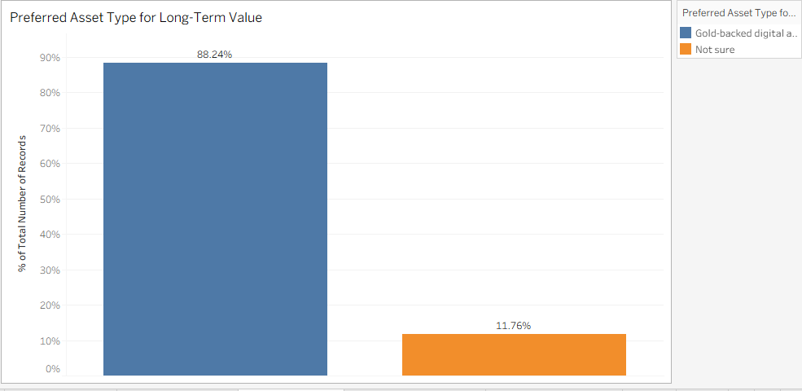
What the chart shows
This chart compares respondents’ preferences for long-term asset types, specifically between gold-backed digital assets and uncertainty about asset choice.
Key insights
A large majority (88.24%) prefer gold-backed digital assets for long-term value.
Only 11.76% of respondents are unsure about which asset type they prefer.
Overall interpretation
The chart indicates strong support for gold-backed digital assets as a long-term store of value. This suggests that combining digital technology with the stability of gold may increase investor confidence compared to traditional cryptocurrencies.

